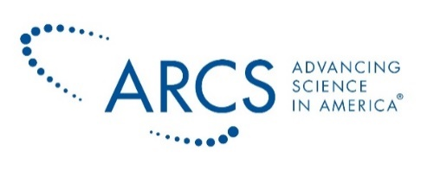

FACT SHEET
HISTORY
The 1957 launch of Sputnik shocked the nation, both fascinating and alarming the American people. For a group of visionary women in Los Angeles, the event sparked an idea. They realized a need for scientific philanthropy to progress the United States’ competitive standing and believed the women in America could make a difference. In 1958, ARCS founders met with the California Institute of Technology President, Lee Dubridge and, together, created a partnership between science and industry.
Sixty-two years later, ARCS Foundation has provided more than 10,500 graduate students of science with awards totaling more than $115 million. Though the areas of science, engineering, and medical research have expanded beyond the original focus on the US space program, the parameters established by our steadfast founders still guide us today in the realization of our mission.
MISSION
ARCS Foundation advances science and technology in the United States by providing financial awards to academically outstanding US citizens studying to complete degrees in science, engineering and medical research.
WHAT WE BELIEVE
It is ARCS Foundation's belief that support of STEM education is essential to US economic growth, technological competitiveness, and continued US leadership in global innovation, health and quality of life.
WHO WE SUPPORT
In collaboration with industry-leading and nationally recognized university departments across the United States, over 1,200 ARCS members from 15 chapters fund the most promising graduate scholars at the startup or “seed stage” of their work and discovery.
- ARCS Approved Academic Partners are universities whose science, technology, engineering, and mathematics departments are ranked in the top 50 in the country.
- All ARCS Scholars are US Citizens, enrolled full-time, with a GPA of 3.5 or higher, and majoring in STEM research fields.
ARCS ALUMNI HALL OF FAME
ARCS Foundation’s highest tribute to a former scholar is the induction into ARCS Alumni Hall of Fame. Inductees have distinguished themselves by demonstrating exceptional leadership in one or more of the following areas:
- Scientific innovation and discovery
- Recognition by peers
- Mentoring future scientists to fill in the STEM pipeline
- Founding or leading an organization that has had a significant impact on the US economy
- Increasing awareness of the importance of national scientific competitiveness
FAST FACTS
- Programs where ARCS Scholars study meet rigorous qualification standards and are approved by ARCS National.
- There are 611 ARCS approved academic departments across 49 universities.
- 93 percent of scholar awards go to graduate students.
- Nine out of 10 ARCS Scholars go on to work in their sponsored fields
- 100% of ARCS scholar award donations go directly to ARCS Scholars.

